Club Service Activities 2004-2006
"Not So Secret Women's Business"

2005-08-12 11:25 GMT
This seminar on women's health was organised jointly by Stanthorpe Community Health and the Zonta Club of Stanthorpe. Venue was The Happy Valley Resort which provided the atmosphere for an excellent day to increase women’s understanding of midlife issues. Participants were comfortable and appreciated the opportunity to network, make new friends and discuss issues of midlife freely.
Guest speakers from Brisbane Toowoomba, Warwick and Stanthorpe addressed a range of topics (Menopause, Diet, Osteoporosis, Laughter Therapy and Sexuality) and were well received by the sixty participants (60). Speakers included Paul Jones (Dietiticians), Dr Kristina Colville (GP), Lynne Newsombe (Osteoporosis Austrialia) and Sandy Collins (sexuality counsellor, Magnolia House).
In summary, when participants were asked how the information would improve on their state of health , the reply was it inspired them to live a healthier lifestyle and that they were also inspired that they would pay particular attention to having regular pap smears, breast checks and dexa scans - to keep a check on osteoporosis. The seminar participants also raised the need for a men’s health seminar to be considered for future planning.
Speakers from last year’s midlife skills have also commented that the seminar had generated many referrals in the areas of Diet, Menopause and Sexuality Counselling.
Proceeds from the seminar will go to Osteoporosis Australia.
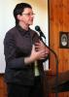 | 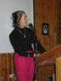 | 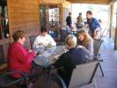 | 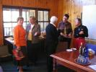 | 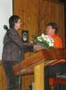 | 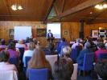
President Pam welcoming participants to the seminar | Chairperson for the Seminar Sandra Bamberry | Participants enjoy lunch on the verandah | Zonta members with Lynn Newcombe | Thank you to Di for all her work with the seminar | Seminar participants

